Spring Cloud Eureka
-------------------------------------------------------------------------------------------------------------------------------
What is Eureka ?
Eureka is a service registry i.e an embedded server provided by Netflix third party which integrates with spring framework.
Main purpose : Micro service registration and discovery with spring cloud and netflix’s eureka.
What is the use of eureka ?
In microservice architecture, we are developing services and exposing each API as service Endpoint and whenever ew required to access other services in simple we are accessing it as a rest client using third party api either rest Template or Client builder.
Architectural Design
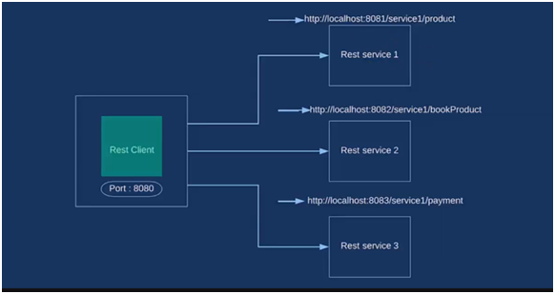

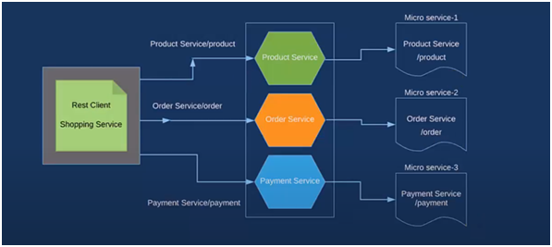
Steps to create Project1 with Eureka Server
Step-1 ) Create eureka server & register one microservice
Step-2)
1. spring boot starter project (amazon-server)
2. Add dependencies – dev tools, eureka server, web
3. @EnableEurekaServer in main
For this we need to add configurations for that so create ‘yml’ file application.yml under resources
Eureka.client.register-with-eureka : false
Server.port : 8761(by default)
Spring.application.name : AMAZON-SERVER
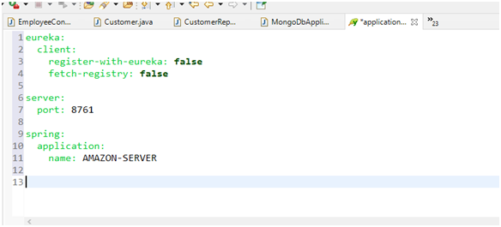

4. Run and check eureka dashboard
Open browser ---- localhost : 8761
Implementation
Creating server
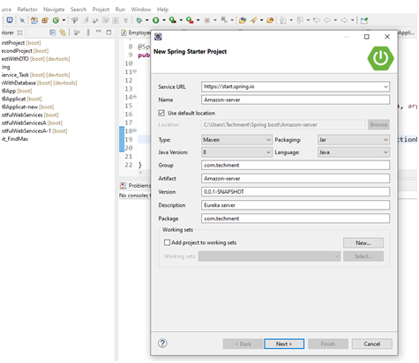

Adding dependencies
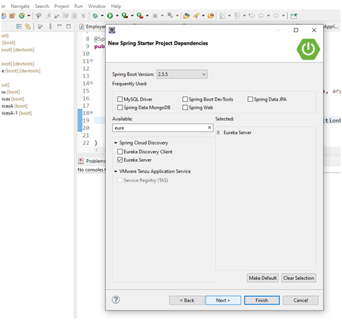

Enabling Eureka Server
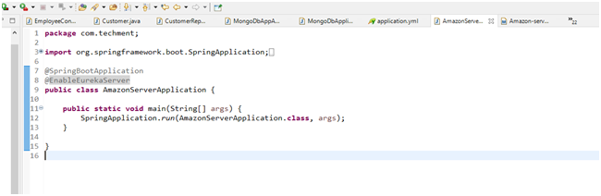
package com.techment;

import org.springframework.boot.SpringApplication;
import org.springframework.boot.autoconfigure.SpringBootApplication;
import org.springframework.cloud.netflix.eureka.server.EnableEurekaServer;

@SpringBootApplication
@EnableEurekaServer
public class AmazonServerApplication {

public static void main(String[] args) {
SpringApplication.run(AmazonServerApplication.class, args);
}
}

Application.yml File

eureka:
client:
register-with-eureka: false
fetch-registry: false

server:
port: 8761

spring:
application:
name: AMAZON-SERVER

POM.xml

<?xml version="1.0" encoding="UTF-8"?>
<project xmlns="http://maven.apache.org/POM/4.0.0" xmlns:xsi="http://www.w3.org/2001/XMLSchema-instance"
xsi:schemaLocation="http://maven.apache.org/POM/4.0.0 https://maven.apache.org/xsd/maven-4.0.0.xsd">
<modelVersion>4.0.0</modelVersion>

<parent>
<groupId>org.springframework.boot</groupId>
<artifactId>spring-boot-starter-parent</artifactId>
<version>2.5.5</version>
<relativePath/> <!-- lookup parent from repository -->
</parent>
<groupId>com.techment</groupId>
<artifactId>Amazon-server-7</artifactId>
<version>0.0.1-SNAPSHOT</version>
<name>Amazon-server-7</name>
<description>Eureka server</description>
<properties>
<java.version>1.8</java.version>
<spring-cloud.version>2020.0.4</spring-cloud.version>
</properties>
<dependencies>
<dependency>
<groupId>org.springframework.boot</groupId>
<artifactId>spring-boot-starter-web</artifactId>
</dependency>
<dependency>
<groupId>org.springframework.cloud</groupId>
<artifactId>spring-cloud-starter-netflix-eureka-server</artifactId>
</dependency>

<dependency>
<groupId>org.springframework.boot</groupId>
<artifactId>spring-boot-devtools</artifactId>
<scope>runtime</scope>
<optional>true</optional>
</dependency>
<dependency>
<groupId>org.springframework.boot</groupId>
<artifactId>spring-boot-starter-test</artifactId>
<scope>test</scope>
</dependency>
</dependencies>
<dependencyManagement>
<dependencies>
<dependency>
<groupId>org.springframework.cloud</groupId>
<artifactId>spring-cloud-dependencies</artifactId>
<version>${spring-cloud.version}</version>
<type>pom</type>
<scope>import</scope>
</dependency>
</dependencies>
</dependencyManagement>

<build>
<plugins>
<plugin>
<groupId>org.springframework.boot</groupId>
<artifactId>spring-boot-maven-plugin</artifactId>
</plugin>
</plugins>
</build>

</project>

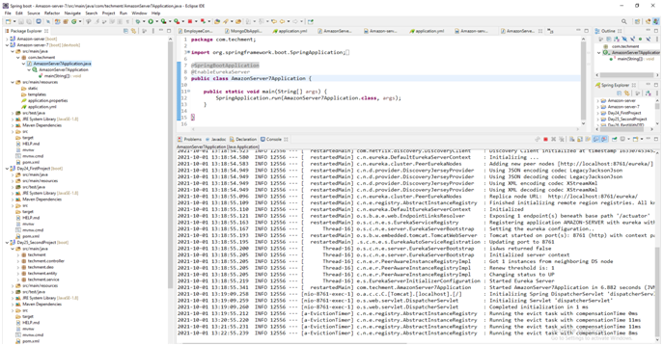

http://localhost:8761/

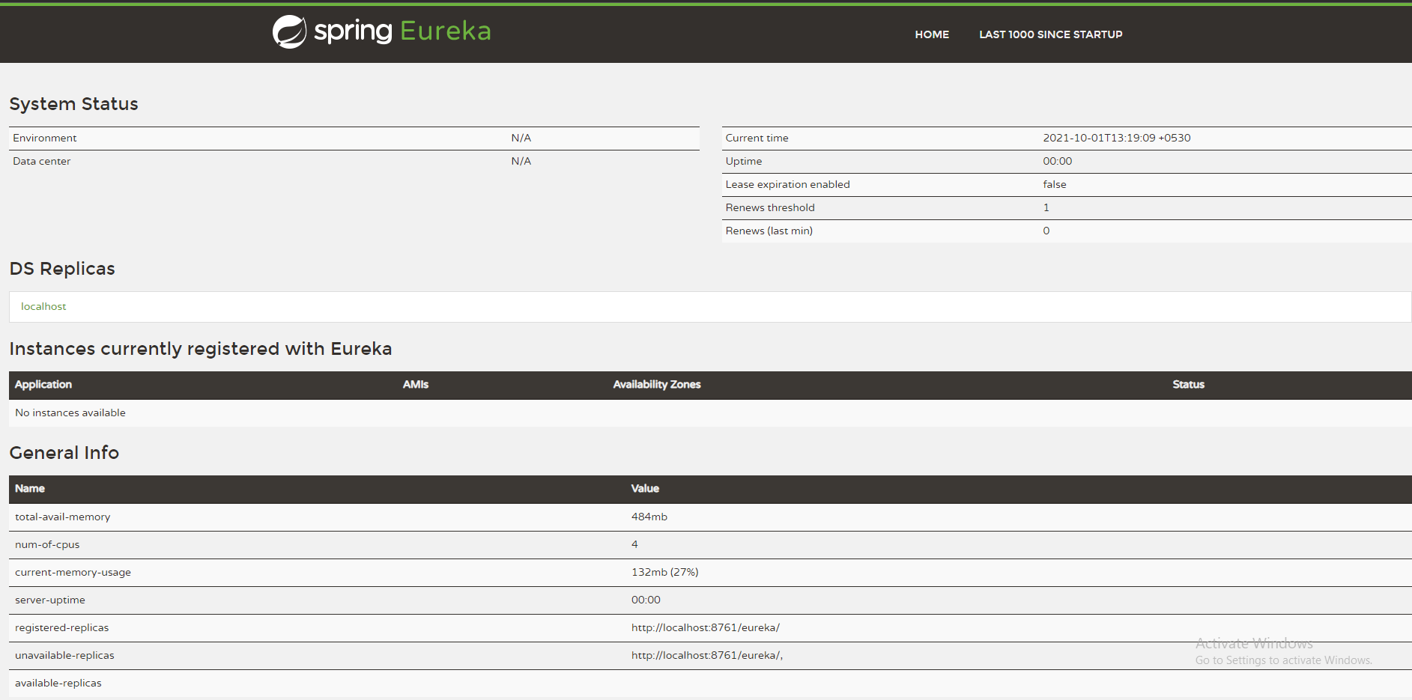

Service-1 ( Payment service )

Payment Service provider consumes from one client and this provider will be registered on eureka server.

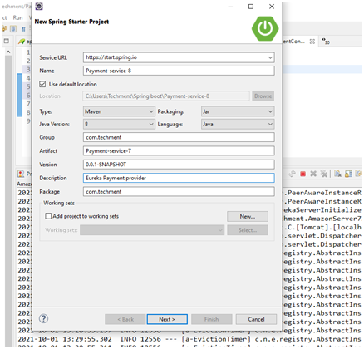

Adding dependencies
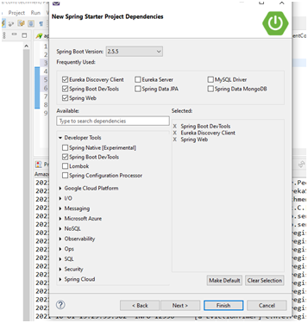

PaymentService7Application.java

package com.techment;

import org.springframework.boot.SpringApplication;
import org.springframework.boot.autoconfigure.SpringBootApplication;
import org.springframework.cloud.netflix.eureka.EnableEurekaClient;

@SpringBootApplication
@EnableEurekaClient
public class PaymentService7Application {

public static void main(String[] args) {
SpringApplication.run(PaymentService7Application.class, args);
}

}

com/techment/controller/PaymentController.java

package com.techment.controller;

import org.springframework.web.bind.annotation.GetMapping;
import org.springframework.web.bind.annotation.RequestMapping;
import org.springframework.web.bind.annotation.RestController;

@RestController
@RequestMapping("/payment-provider")
public class PaymentController {

@GetMapping("/payNow/{price}")
public String payNow(int price) {
return "Payment with " + price + "is successful";
}
}

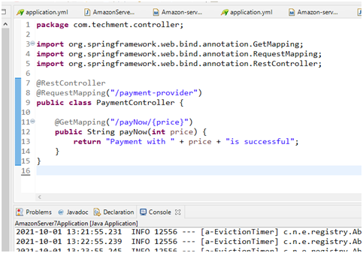

Register this provider ---- for that make yml file

eureka:
client:
register-with-eureka: true
fetch-registry: true
serviceUrl:
defaultZone : http://localhost:8761/eureka/
instance:
hostname: localhost
server:
port: 8762
spring:
application:
name: PAYMENT-SERVICE

Service Registered
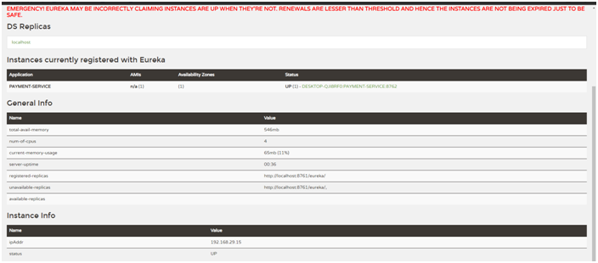

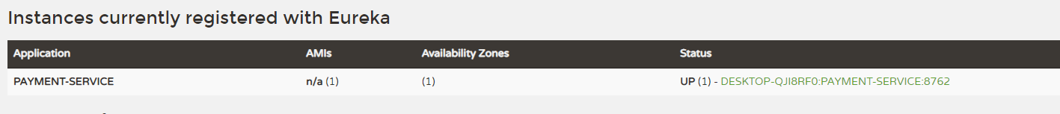

Development of client from client will access this payment service

/amazon-shopping

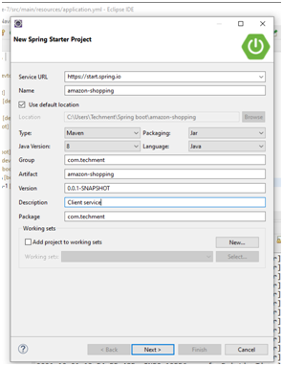

AmazonShoppingApplication.java

package com.techment;

import org.springframework.boot.SpringApplication;
import org.springframework.boot.autoconfigure.SpringBootApplication;
import org.springframework.cloud.client.loadbalancer.LoadBalanced;
import org.springframework.cloud.netflix.eureka.EnableEurekaClient;
import org.springframework.context.annotation.Bean;
import org.springframework.web.client.RestTemplate;

@SpringBootApplication
@EnableEurekaClient
public class AmazonShoppingApplication {

@LoadBalanced
@Bean
public RestTemplate getTemplate () {
return new RestTemplate();
}

public static void main(String[] args) {
SpringApplication.run(AmazonShoppingApplication.class, args);
}
}

ShoppingController.java

package com.techment.controller;

import org.springframework.beans.factory.annotation.Autowired;
import org.springframework.web.bind.annotation.GetMapping;
import org.springframework.web.bind.annotation.PathVariable;
import org.springframework.web.bind.annotation.RestController;
import org.springframework.web.client.RestTemplate;

@RestController
public class ShoppingController {

@Autowired
private RestTemplate template;

@GetMapping("/amazon-payment/{price}")
public String invokePaymentService(@PathVariable int price) {

// String url = "http://localhost:8762/payment-provider/payNow/" + price;
String url = "http://PAYMENT-SERVICE/payment-provider/payNow/" + price;

return template.getForObject(url, String.class);
}
}

Application.yml

eureka:
client:
register-with-eureka: true
fetch-registry: true
serviceUrl:
defaultZone : http://localhost:8761/eureka/
instance:
hostname: localhost
server:
port: 8763
spring:
application:
name: SHOPPING-SERVICE

POM.xml

<?xml version="1.0" encoding="UTF-8"?>
<project xmlns="http://maven.apache.org/POM/4.0.0" xmlns:xsi="http://www.w3.org/2001/XMLSchema-instance"
xsi:schemaLocation="http://maven.apache.org/POM/4.0.0 https://maven.apache.org/xsd/maven-4.0.0.xsd">
<modelVersion>4.0.0</modelVersion>
<parent>
<groupId>org.springframework.boot</groupId>
<artifactId>spring-boot-starter-parent</artifactId>
<version>2.5.5</version>
<relativePath/> <!-- lookup parent from repository -->
</parent>
<groupId>com.techment</groupId>
<artifactId>amazon-shopping</artifactId>
<version>0.0.1-SNAPSHOT</version>
<name>amazon-shopping</name>
<description>Client service</description>
<properties>
<java.version>1.8</java.version>
<spring-cloud.version>2020.0.4</spring-cloud.version>
</properties>
<dependencies>
<dependency>
<groupId>org.springframework.boot</groupId>
<artifactId>spring-boot-starter-web</artifactId>
</dependency>
<dependency>
<groupId>org.springframework.cloud</groupId>
<artifactId>spring-cloud-starter-netflix-eureka-client</artifactId>
</dependency>

<dependency>
<groupId>org.springframework.boot</groupId>
<artifactId>spring-boot-devtools</artifactId>
<scope>runtime</scope>
<optional>true</optional>
</dependency>
<dependency>
<groupId>org.springframework.boot</groupId>
<artifactId>spring-boot-starter-test</artifactId>
<scope>test</scope>
</dependency>
</dependencies>
<dependencyManagement>
<dependencies>
<dependency>
<groupId>org.springframework.cloud</groupId>
<artifactId>spring-cloud-dependencies</artifactId>
<version>${spring-cloud.version}</version>
<type>pom</type>
<scope>import</scope>
</dependency>
</dependencies>
</dependencyManagement>

<build>
<plugins>
<plugin>
<groupId>org.springframework.boot</groupId>
<artifactId>spring-boot-maven-plugin</artifactId>
</plugin>
</plugins>
</build>

</project>

Service - Registered

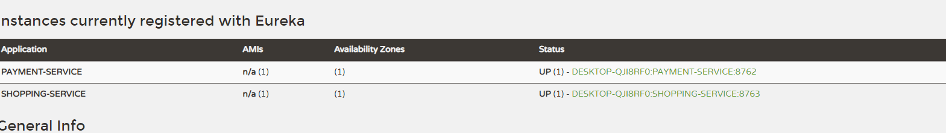

Last Step - Check API in Postman





